**Cisco ASA 55XX**

Remember that the P1 interface on the V10K needs to be on the same Vlan as the internal interface of the Cisco ASA.

**Global Configuration:**

#wccp 0 [Enables service group 0 for http traffic]

#wccp interface inside 0 redirect in [Inside interface redirects http traffic to the proxy]

#wccp 0 redirect-list 100 [Access list applied to service group 0]

**Example ACL**

**Access List 10:**

Access-list 100 deny tcp any 172.16.5.0 0.0.0.255 (*Extended ACL*)

*Keeps users from using the proxy when accessing web interfaces in the DMZ*

**Other Options:**

Access-list 100 deny tcp 10.20.0.0 0.0.255.255 172.16.5.0 0.0.0.255 (*Extended ACL*)

*Keeps users on the 10.20.0.0/16 from using proxy when connecting to the DMZ*

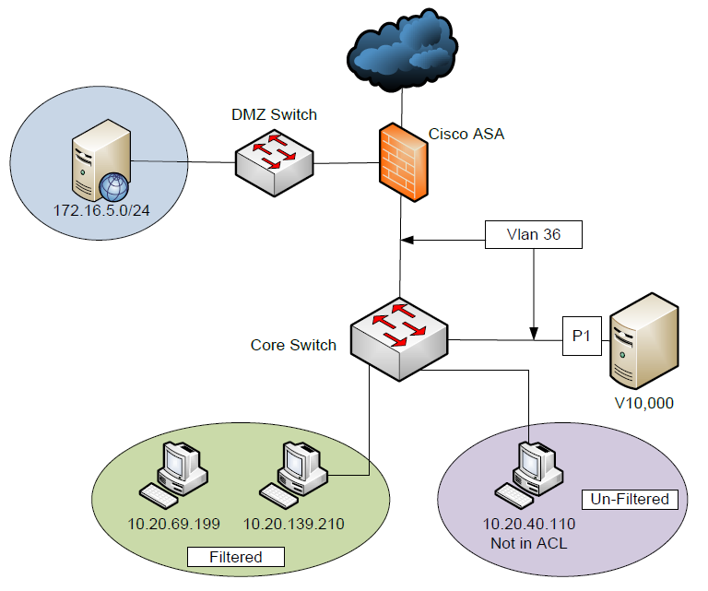

**Note:**

You may not have the ability to use a stand access list with a WCCP configuration on an ASA. Better to stick with the extended ACLs.